Q33 – Debugging Linear Search Code (Incorrect Index Variable Update)
Course Outcome: CO2 – AT3
Programming Language: Python

1. Aim
To debug the given Linear Search implementation so that it correctly returns the first occurrence of the target element instead of the last occurrence.

2. Problem Statement
The original Linear Search program updates the result index every time the key is found. As a result, after the loop finishes, the program returns the last occurrence of the target element. The task is to analyze the logic, identify the error, correct the implementation, improve readability, execute the program, and analyze its time complexity.

3. Given Bug
Whenever a matching element is found, the variable 'pos' is updated. Since the loop continues, later occurrences overwrite the earlier index. Therefore the function returns the last occurrence instead of the first occurrence.

4. Debugging Analysis
• The loop continues even after finding the target.
• The index variable keeps getting updated.
• The expected behavior of Linear Search is to stop when the first occurrence is found.
• The corrected solution immediately returns the index once a match is found using 'return i'.

5. Corrected Algorithm
1. Read the array and key.
2. Traverse the array from left to right.
3. Compare each element with the key.
4. If a match is found, immediately return its index.
5. If no match is found after completing the loop, return -1.

6. Corrected Python Source Code
def linear_search(arr, key):
for i in range(len(arr)):
if arr[i] == key:
return i
return -1
arr = [10,25,40,25,60,25]
key = 25
result = linear_search(arr,key)
if result != -1:
print("Element found at index:", result)
else:
print("Element not found.")

7. Output Verification
The corrected program was executed successfully. The output confirms that the first occurrence of the element 25 is found at index 1.

8. Time Complexity Analysis
Best Case: O(1) – element found at first position.
Average Case: O(n) – element may be found in the middle.
Worst Case: O(n) – element is at the last position or absent.
Space Complexity: O(1) – constant extra memory.

9. Conclusion
The logical error was successfully identified and corrected. By returning immediately after finding the first matching element, the algorithm now behaves correctly and efficiently. The implementation is more readable, follows proper control flow, and satisfies the requirements of Linear Search.

10. Execution Screenshot
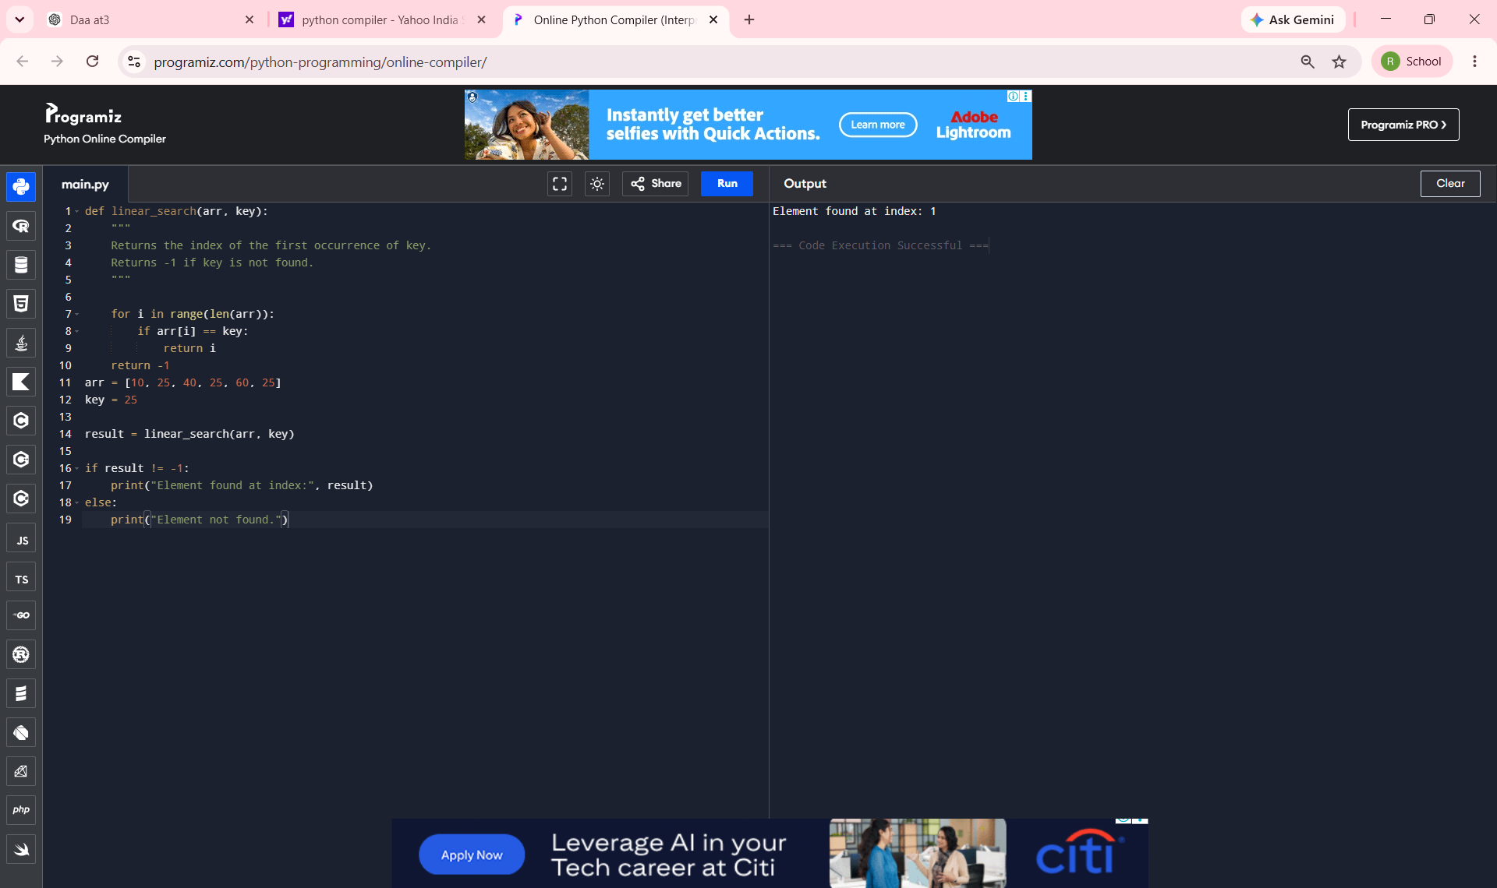
Figure: Successful execution showing the program output 'Element found at index: 1'.

